4th March 2014
FOR IMMEDIATE RELEASE

URBAN ALLIGATORS AND ALTERNATE DIMENSIONS
British illustrator creates art book of Manhattan myths

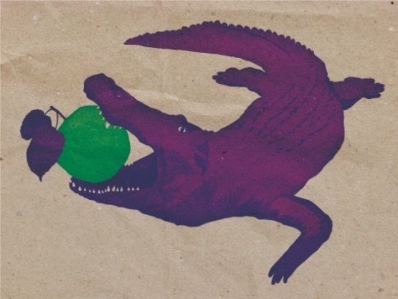
Freelance illustrator J M Cooper heads to NYC to explore the weird side of Manhattan. Pending a successful Kickstarter campaign, the artist will spend a month roaming the streets and interviewing the inhabitants to create an art book of illustrated oddities, urban myths, and strange rumors.
Strange Island - 30 Days of Manhattan Weirdness Illustrated

“I see it as an adventure, really. A perilous journey through a different Manhattan, like an alternate reality. So in this other dimension, there really are alligators in the sewers and ghosts in the park, and I’m going to go and draw this alternate city and all the strange things there.” - J M Cooper
J M has been working as a freelance illustrator for four years, specialising in vector illustration for clients worldwide. Should the Kickstarter campaign be successful, she will spend 30 days living in NYC to work on the Strange Island project full time.
“I spent some time in NYC a couple of years ago and fell in love, it’s a place like no other. But wherever you have people living in such close proximity, strange rumours and myths start to develop – it happens everywhere. I wanted to make this book about Manhattan because it has such a wealth of myths and legends and general strangeness, but also because it’s so famous. Everyone has their own version of it in their heads, whether they’ve been there or not.”
Everyone who backs the project will receive a reward, ranging from hand drawn postcards and copies of the finished art book to bespoke prints and commissions. Around half of the $3700 goal has already been raised and the campaign runs until Sun, Mar 23 2014.
Back Strange Island - 30 Days of Manhattan Weirdness Illustrated here: kck.st/1fR1GR9
Updates @ManhattanWeird
Illustration portfolio: www.jmcooperart.com
Online press release: http://www.jmcooperart.com/strange-island-press-release.html

About J M Cooper
J M Cooper is a professional freelance illustrator who loves her job. She creates strange and beautiful vector illustrations for international clients.When not glued to her computer she enjoys science fiction, a nice glass of wine, and beating everyone at scrabble.
Contact for more info:
jmcooper@jmcooperart.com UK: 07584417343 SKYPE: jmcooperart
###

